**ST. THEREZA NAMIRYANGO GIRLS’ BOARDING PRIMARY SCHOOL**

**END OF TERM I CONTINUOUS ASSESSMENT 2024**

**P.3 MATHEMATICS**

**TIME ALLOWED: 2 HOURS 30 MINUTES**

**NAME__________________________________________STM__**

**SECTION A (40 MARKS)**

1. Subtract;

**T O**

5 4

1 3

2. Name the set symbol below.

Ս **_____________**

3. Complete correctly;

4 thousands $+$ 0 hundreds $+$ 6 tens 3 ones = _____

4. Add;

**H T O**

2 4 5

3 5 8

5. Shade

6. Circle the larger number.

310 and 130

7. Solve;

8 = 15

8. Show 8 O’clock on the clock face below.

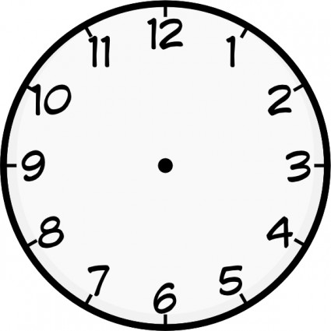

9. Work out;

One cow has 2 horns. How many horns do 7 cows have?

10. Show 6502 on the abacus below.

**Th H T O**

11. Share 18 litres of milk among 3 boys. How many litres

of milk does each boy get?

12. Count in tens and fill in correctly.

560, 570, _____ , 590 , _____ .

13. Complete correctly;

___ ___ ___

14. Change XXIII to Hindu Arabic Numerals.

15. Given that set W = { a, e, i , o ,u }

How many members are in set W?

16. Multiply;

3 4

3

17. Work out;

Mugisha had 234 apples. She sold off 128 apples. How many apples remained?

18. Write four thousand two hundred forty-five in figures.

19. Divide;

5 4 5

20. Jacob has Sh. 400. Peter has sh. 500. How much

money do they have altogether?

**SECTION B (60 MARKS)**

21(a) Write four tenths in figures.

(b) Work out;

i) $\frac{3}{7} + \frac{2}{7} + \frac{1}{7} =$

ii) $\frac{9}{13} - \frac{6}{13} =$

22(a) Multiply;

**H T O**

3 5 0

$×$ 3

(b) Find the value of 4 in 346.

**__________________________________**

(c) Complete correctly;

4 $+$ 4 $+$ 4 $+$ 4 $+$ 4 is the same as ___ x ___ = ____

23. Atukei’s shopping list.

|  |  |
| --- | --- |
| **Item** | **Cost** |
| A book | Sh. 800 |
| A rubber | Sh. 500 |
| A ruler | Sh. 900 |
| A pen | Sh. 500 |

a) What is the most expensive item?

b) How much will Atukei pay for a book and a pen?

c) Which items cost the same amount of money?

d) Work out;

Sh. 2 0 0 0

Sh. 9 0 0

24. Solve;

(a) 4 9 (b) 3 6

(c) 4 12

25. **Study the travel plan of Mr. Kityo and answer the**

**questions about it.**

**Poultry**

**house**

**Kraal**

**Kennel**

**Pig sty**

25m

15m 10m

35m

a) What is the distance from the poultry house to the Kraal?

b) Find the total distance from the pig sty to the poultry house through the Kraal.

c)Work out the total distance round the four places.

d) State the shortest distance on Mr. Kityo’s travel plan in metres.

26. Work out using a number line**.**

a) 7 $-$ 3 = ______

**0 1 2 3 4 5 6 7 8 9 10**

b) 2 $×$ 4 = ______

**0 1 2 3 4 5 6 7 8 9 10**

27(a) Write the place value of the underlined digit in

the number below.

i) 2**4**78 ii) **4**620

(b) Expand using values;

i) 25 =

ii) 657 =

28. Study the sets below and answer the questions that

follow.

**X Y Z**

a) Which set has the least number of elements?

b) How many elements are in set X?

c) List the elements of set Y.

Set Y =

29. Work out;

(a) **Th H T O**

7 6 9 6

$-$ 2 8 9

(b) Find the product of 12 and 3.

(c)What is the sum of 250 pupils and 370 pupils?

30. **Complete the table below.**

|  |  |  |  |  |  |
| --- | --- | --- | --- | --- | --- |
| Number of tables | 1 | 2 | 5 | 3 | 6 |
| Number of legs | 4 | ___ | ___ | ___ | ___ |

31. Work out and complete the table

6

4 2

3

12

32. **The bar graph below shows the number of pupils who reported back from Easter break in each stream. Study it and answer the questions that follow.**

100

80

60

40

20

0

**Number of pupils**

**Divers Ravers Penguins Roses Larkspurs**

**Streams**

(a) Which stream had the highest number of pupils?

(b) How many pupils reported back in Penguins?

(c) Which streams had the same number of pupils?

(d) Identify the stream which had 40 pupils.

**End**